

Oracle Integration

REST Interface

USER GUIDE

**Version: 1.0  
Document Revision: 1.0**



Contents

1. Introduction 3

2. Solution Overview 4

3. Pre-Requisites and Environment Configuration 5

3.1. Oracle Integration Cloud Access 5

3.2. Blue Prism Configuration 5

3.3. JSON Encoded Parameters for *Start Process* 6

4. Using the Skill 8

4.1. Get Process Definitions 8

4.2. Start Process 9

5. Support 10

The information contained in this document is the proprietary and confidential information of Blue Prism Limited and should not be disclosed to a third party without the written consent of an authorised Blue Prism representative. No part of this document may be reproduced or transmitted in any form or by any means, electronic or mechanical, including photocopying without the written permission of Blue Prism Limited.

**© Blue Prism Limited, 2001 – 2018**®Blue Prism is a registered trademark of Blue Prism Limited

All trademarks are hereby acknowledged and are used to the benefit of their respective owners.  
Blue Prism is not responsible for the content of external websites referenced by this document.

Blue Prism Limited, Centrix House, Crow Lane East, Newton-le-Willows, WA12 9UY, United Kingdom  
Registered in England: Reg. No. 4260035. Tel: +44 870 879 3000. Web: www.blueprism.com

# Introduction

Oracle Integration Service simplifies how you build integrations in the cloud, letting you connect securely to applications and services both in the cloud and on-premises. Oracle Integration is a comprehensive, best-in-class platform with hundreds of out-of-the-box adapters to seamlessly integrate on-prem and cloud applications along with real-time, fault-tolerant data integration and replication services supporting a wide variety of on-prem and cloud databases.

This skill is designed to give Blue Prism Digital Workers the means to execute processes defined within the Oracle Integration environment. This skill exposes a subset of REST endpoints for the Oracle Integration platform.

The actions which are wrapped by this skill include:

* Get Process Definitions
* Start Process

This document describes how to make use of these actions.

**NOTE:** Detailed information regarding the Oracle Integration REST API is available at:

<https://docs.oracle.com/en/cloud/paas/integration-cloud/rest-api/index.html>

# Solution Overview

This skill wraps a subset of the REST endpoints available on the Oracle Integration REST interface. Additional endpoints are available on the service and may be added to this skill in the future.

# Pre-Requisites and Environment Configuration

## Oracle Integration Access

Use of this skill requires access to either an on-premise or cloud-based instance of Oracle Integration. Furthermore, you will have to have a user account with sufficient permission to execute methods against the REST interfaces.

## Blue Prism Configuration

After you have imported the skill into your Blue Prism environment, you must update the details of the Oracle credential template that was created for you in Credential Manager. The credential is named ***Oracle Integration***.

To update the credential details:

1. Open Blue Prism Interactive Client
2. Go to ***System → Security → Credentials***
3. Double-click on the entry titled ***Oracle Integration***
4. Enter the username and password of the IBM user account you will use

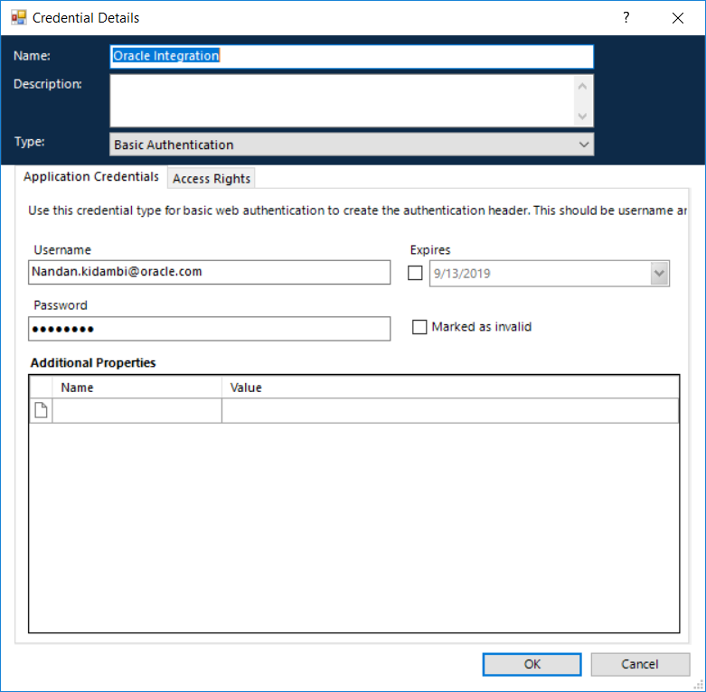

1. Next, click on the tab title ***Access Rights***.
2. Select an appropriate ***Security Role***, set the ***Processes*** that should have access to this credential, and specify which ***Resources*** can make use of the credential.

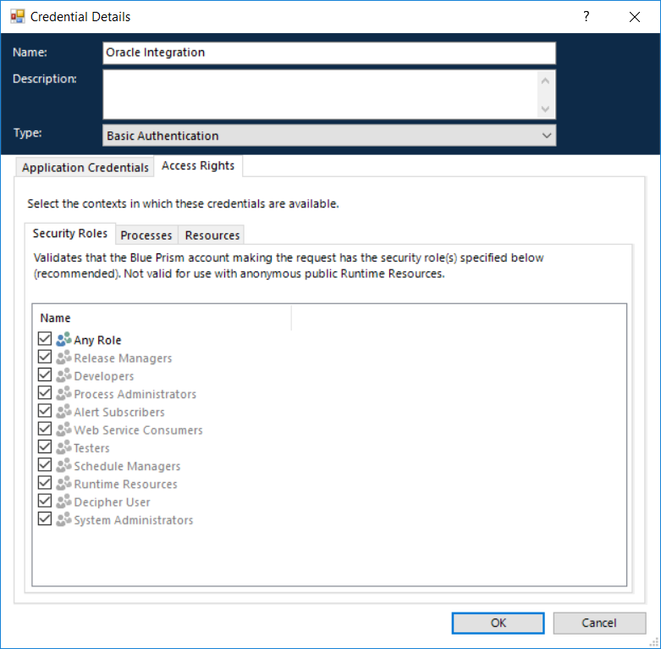

**NOTE:** Oracle Integration Cloud supports HTTP Basic and OAuth2 authentication schemes. This credential defaults as HTTP Basic. If your company utilizes OAuth2 within OIC, you must change the type of credential to OAuth2 and then set the necessary security values.

## JSON Encoded Parameters for *Start Process*

Some published processes within OI will require that you pass them input parameters in order to successfully start the process. The parameters, their data types, and expected values are specific to each process. The action ***Get Process Definitions*** will include a list of the expected parameters for every published process.

It is your responsibility to prepare those input parameters as a JSON object, as required by OI. Here is an example JSON object for a mock OI process called TWP Exceptions:

{

"requestorId" : "john.doe@oracle.com",

"requestorName" : "John Doe",

"requestorEmailId": "john.doe@oracle.com",

"exceptionCode": "NT",

"exceptionLevel": "ERROR",

"invoiceNumber": "1134567890",

"fileName": "InvoicePDF",

"vendorName": "Acme Inc.",

"apDistroEmail": "john.doe@oracle.com",

"taxDistroEmail": "john.doe@oracle.com"

}

# Using the Skill

Below are the available actions in the skill and the details of the inputs/outputs that are available.

## Get Process Definitions

This action will return a collection containing information about any published process on the OIC instance.

### Inputs

|  |  |  |
| --- | --- | --- |
| Parameter | Type | Description |
| Base URL | Text | **Required** - The base URL of your Oracle Integration instance. |

### Outputs

|  |  |  |
| --- | --- | --- |
| Parameter | Type | Description |
| Processes | Collection | A collection containing the following data items for each published process:  - processDefId  - processName  - revision  - serviceName  - operation  - startType  - parameters  * See your Oracle Integration documentation for further information about these values. |

## Start Process

Creates a new process instance or saves a process instance based on the value of action in the input.

### Inputs

|  |  |  |
| --- | --- | --- |
| Parameter | Type | Description |
| Base URL | Text | **Required** - The base URL of your Oracle Integration instance. |
| ProcessDefId | Text | **Required** - The process definition ID captured from the process definition information returned from OI. |
| Operation | Text | **Required** - The text value representing the operation name as presented in the process definition information. |
| ServiceName | Text | **Required** - The name of the service as presented in the process definition information. |
| Params | Text | A JSON string containing the required input parameters and their values as defined in the process definition information. |

### Outputs

|  |  |  |
| --- | --- | --- |
| Parameter | Type | Description |
| title | Text | See your OI documentation for further information about this value. |
| processId | Text | See your OI documentation for further information about this value. |
| processDefId | Text | See your OI documentation for further information about this value. |
| processName | Text | See your OI documentation for further information about this value. |
| priority | Number | See your OI documentation for further information about this value. |
| owner | Text | See your OI documentation for further information about this value. |
| creator | Text | See your OI documentation for further information about this value. |
| state | Text | See your OI documentation for further information about this value. |
| links | Text | See your OI documentation for further information about this value. |

# Support

Support for this skill is provided via the Blue Prism Digital Exchange Community Forum. Post your questions here:

[Digital Exchange Community Forum](https://community.blueprism.com/communities/community-home?communitykey=1e516cfe-4d1f-4de9-a9eb-58d15bf38c81&tab=groupdetails)